Closing a scheme

Contents

[Introduction 2](#_Toc153371999)

[Identify whether old or new style calculator 2](#_Toc153372000)

[Closing a new style Scheme 3](#_Toc153372001)

[Closing an old style Scheme 5](#_Toc153372002)

[Simple referral for all business with immediate effect 5](#_Toc153372003)

[Refer from a specific end date 5](#_Toc153372004)

[Refer a specific quote stage 6](#_Toc153372005)

[Test the Scheme in TGSL 7](#_Toc153372006)

[Release to live TGSL 8](#_Toc153372007)

[New style Scheme (calculator function) 8](#_Toc153372008)

[Old style Scheme (WPD file) 8](#_Toc153372009)

# Introduction

This document assumes an understanding of Schemes and calculators. For more information see the Creating a new Scheme.docx documentation in one of the following locations:

* GIT\Documentation\Scheme
* <https://constructaquote.monday.com/boards/671792066/pulses/674060287>

From time to time Schemes need to be closed so that they no longer quote. This is usually achieved by setting all risks to refer. There may be different criteria, i.e. only applying to New Business or Renewals, and it may need to be future dated, but this document gives an overview and some common scenarios.

# Identify whether old or new style calculator

Historically, the calculator logic has been built into files called WPDs (the file extension is .wpd) with calculations written in TGSL’s proprietary TCAS calculator language. New style schemes still require a WPD file to interface with TGSL. However, a standard file is now created which acts as little more than a link, providing the risk information to SQL procedures, functions and views that exist in the Calculators database.

1. Launch SQL Server management Studio and connect to **MHGSQL01\TGSLTEST**
2. Expand the **Calculators** database and then expand the **Tables** folder
3. Look for a table named “<Product code>\_<Insurer>\_<Product>\_Trade…” or “<Product code>\_<Insurer>\_<Product>\_Rate…” for the Scheme you need to change. For example if the change is for the Covea Small Business and Consultants Liability Scheme you can see there is a trade table for this:  
   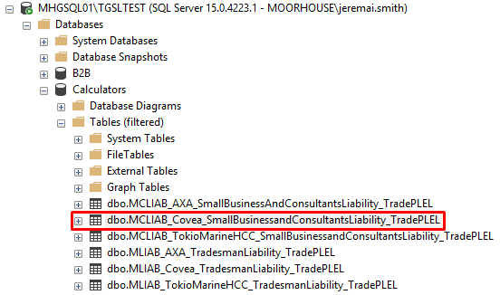  
   Note, the Tables folder can be filtered by right-clicking and selecting **Filter > Filter Settings** to help find a table.

|  |
| --- |
| **If you find tables for the Scheme, this means it already has a new style calculator. Follow the instructions for** [**Closing a new style Scheme**](#_Changing_a_new) **below.**  **If the Product does NOT already have a new style calculator, follow the instructions for** [**Closing an old style Scheme**](#_Changing_and_old) **below.** |

# Closing a new style Scheme

The easiest way to close a new style scheme is to add the refer rule to the tvfSchemeDispatcher function for the Product, similar to the way that a Pound Scheme works.

1. Still within SQL Server management Studio connected to **MHGSQL01\TGSLTEST**, expand the **Calculators** database and then filter the TVF list by expanding the **Programmability** folder, **Functions** subfolder, and right-clicking on **Table-valued Functions**, then selecting **Filter** and **Filter Settings**:  
   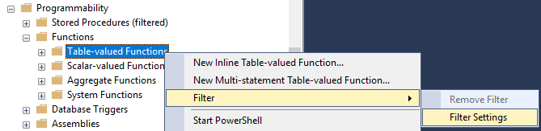
2. Enter a filter for Name contains “tvfSchemeDispatcher”:  
   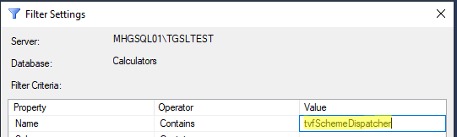
3. Click **OK**
4. Expand the filtered TVF folder to see all the functions that match the filter:  
   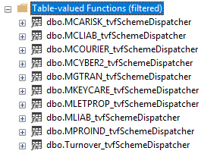
5. Locate the function for the Product code of the Scheme that needs to be closed. For example, if you need to close a Small Business and Consultants Liability Scheme, it’s the MCLIAB\_tvfSchemeDispatcher. (If unsure of the Product code for your Product, look up the PRODUCTTYPE\_ID in the RM\_PRODUCT table in the Transactor\_Live database, then query the SYSTEM\_LIST\_PRODUCTTYPE\_ALIAS table for this ID.) Right-click on the function and click **Modify**.
6. The TVF script will open in a new query window. Locate the section that calls the calculator function for the SCHEMETABLE\_ID of the Scheme to be closed. It will look something like this:  
   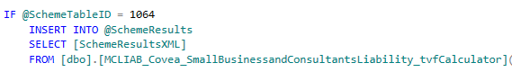  
   If unsure of the SCHEMETABLE\_ID, it can be found using the following query (changing the insurer name as required):  
   SELECT \* FROM RM\_SCHEME WHERE NAME LIKE 'Towerg%'
7. If it is the only SCHEMETABLE\_ID in the IF statement, comment out the whole statement, otherwise just comment out the ID of the scheme to be closed, e.g.:  
   
8. Scroll down to the end to locate the “Refer Scheme” section that refers Pound Schemes with an ‘Automatic Referral’ message:  
   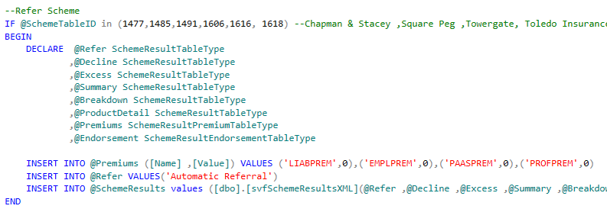
9. Copy and paste this section of code immediately below
10. Change the SchemeTableID to the ID of the Scheme to be closed as highlighted below
11. Add any additional rules for the closure. The following example is effective from a future date and only applies to New Business as outlined in red below. These are optional and depend on what has been requested on the ticket:  
    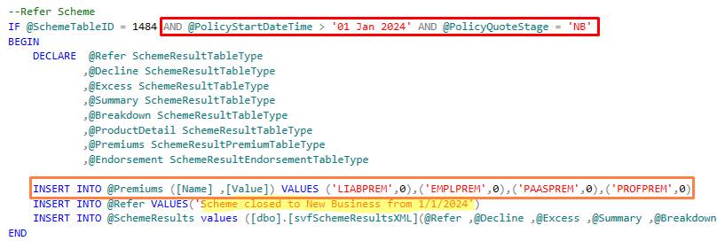
12. Update the refer message to state that the Scheme has closed with any other relevant information similar to the example highlighted above.
13. The orange outline above shows premiums being set to zero. The ticket may or may not request that premiums be cleared for the closed Scheme so that it behaves like a Pound Scheme. If it does not request this, this line can be commented out or removed.  
    NOTE: There is some difference between Products as to whether Pound Scheme premiums are set in the tvfSchemeDispatcher, or premiums are set to £1 for all referrals in the <Product code>\_uspCalculator stored procedure. For a full explanation and instructions see the separate Creating a new Pound Scheme. docx documentation in one of the following locations:
    * GIT\Documentation\Scheme
    * <https://constructaquote.monday.com/boards/671792066/pulses/671836074>
14. Save the modified function script in a new subfolder in the following location:   
    L:\Public\IT\Development\Tickets\Monday  
    The new subfolder can be named with the ticket number from the Monday.com board. The script will be used later for the live release.
15. Execute this script, making sure you are connected to the UAT server (MHGSQL01\TGSLTEST)
16. Proceed to the [Test the Scheme in TGSL](#_Test_the_Scheme) section below

# Closing an old style Scheme

If trade and rate tables are not found in the Calculator database, then the Scheme has an old style calculator with logic built into the WPD file. The WPD file will be amended to close the Scheme.

1. Still within SQL Server management Studio connected to **MHGSQL01\TGSLTEST**, run the following query in the **Transactor\_Live** database, changing the insurer name as required:  
   SELECT \* FROM SYSTEM\_SCHEME\_DEFINITIONS WHERE PRODUCTNAME LIKE 'Axa%'  
   This will show the names of the WPD files for the various Schemes:  
   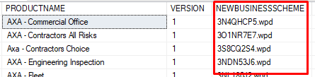
2. Launch File Explorer and navigate to L:\Test\TCAS\Schemefiles
3. Take a copy of the WPD file for the Scheme that needs to be changed and save it in a new subfolder in the following location:  
   L:\Public\IT\Development\Tickets\Monday  
   The new subfolder can be named with the ticket number from the Monday.com board.
4. In a text editor, open the WPD file from L:\Test\TCAS\Schemefiles for the Scheme that needs to be changed (don’t open the copy; that’s just in case you need to reinstate the original version)

|  |  |
| --- | --- |
| **TIP:** To make working with WPD files easier, you can use a user defined language in Notepad++ to change the colour of keywords and comments. In Notepad++ click on **Language > User Defined Language > Define your language…** In the window the opens, click **Import** and load the file GIT\TGSL\LineOfBusiness\Tools\WPD user defined language for Notepad++.xml. Then, after opening a WPD file in Notepad++, click on **Language** and select **WPD**. |  |

1. Add a referral to the WPD. The syntax will depend on what has been requested on the ticket, for example whether it only applies to New Business or Renewals, and if it is future dated. Some examples of different scenarios are shown below.

## Simple referral for all business with immediate effect

If there is no effective date or quote stage restriction, the following code can simply be pasted almost at the end of the script, just before the closing “{End Product}End Product” tag:

{Refer}Refer

{Remark}{TypeString}Please telephone insurer to obtain a Quote

{TypeString}Refer all - scheme closed

{End Refer}End Refer

This will refer everything with immediate effect.

## Refer from a specific end date

If the Scheme needs to refer quotes with an effective date greater than a specific date, new variables will need to be created to store the end date, and to calculate the difference between this end date and the effective date of the quote. The following example shows this logic.

Note that the variables (called “Workfields”) have their data type defined by a trailing character: the carat symbol (^) is for a date, and the percentage symbol is for a numeric field.

This code needs to be added within the “{For Each}Policy\_Details” section of the script.

{Equation}Equation

{TypeWorkfield}SchemeEndDate^

{Operator=}=

{TypeString}01/01/2024

{End Equation}End Equation

{Equation}Equation

{TypeWorkfield}days%

{Operator=}=

{TypeConstant}0

{End Equation}End Equation

{DateDiff}DateDiff

{TypeWorkfield}days%

{Operator=}=

{TypeWorkfield}SchemeEndDate^ {TypeQuestion}Client.Policy\_Details.Policy\_Start\_Date

{TypeString}d

{TypeBoolean}true

{End DateDiff}End DateDiff

{If}If

{Truth}Truth

{TypeWorkfield}days%

{Operator>}>

{TypeConstant}0

{End Truth}End Truth

{Refer}Refer

{TypeString}Scheme set to refer from 01/01/2024

{End Refer}End Refer

{Equation}Equation

{TypeWorkfield}Referral?

{Operator=}=

{TypeBoolean}True

{End Equation}End Equation

## Refer a specific quote stage

If the Scheme needs to only refer New Business or Renewals, this is held in the Pol\_QuoteStage field. The following example shows the logic, combined with an effective date restriction as above. This would replace the final section shown above, i.e. after setting the “days%” variable has been set.

Again, this code needs to be added within the “{For Each}Policy\_Details” section of the script.

{If}If

{Truth}Truth

{TypeQuestion}Client.Policy\_Details.Pol\_QuoteStage

{Operator=}=

{TypeString}NB

{End Truth}End Truth

{If}If

{Truth}Truth

{TypeWorkfield}days%

{Operator>}>

{TypeConstant}0

{End Truth}End Truth

{Refer}Refer

{TypeString}Scheme closed to New Business from 1/1/2024

{End Refer}End Refer

{Equation}Equation

{TypeWorkfield}Referral?

{Operator=}=

{TypeBoolean}True

{End Equation}End Equation

{End Product}End Product

{End If}End If

{End If}End If

1. Save the changes to the amended WPD file in L:\Test\TCAS\Schemefiles
2. Proceed to the [Test the Scheme in TGSL](#_Test_the_Scheme) section below

# Test the Scheme in TGSL

1. Launch a remote desktop connection to MHGTGSL01Test
2. Click the start button and search for TCAS, then click to open:  
   
3. Log in
4. Perform an enquiry to find a suitable test customer:  
   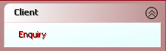

Client Search 
Search By 
O 
Policy/Quote Number 
Surname and/or Postcode 
• 
O 
Surname and Renewal Date 
O 
Surname and Date of Birth 
O 
Registration Number 
O 
Invoice Number 
O 
Client Reference 
O 
Company Name and/or Postcode 
O 
Insurer Policy Number 
O 
Claim Number 
O 
Telephone Campaign 
Sumame/Co_ Name Clements 
Postcode CFB3 2RA 
Cancel 

1. Once you've found a client then click **Policies**. If you already have a Policy Type for the appropriate Product click **Amend** and skip the next step. Otherwise click **Add Quote**:  
   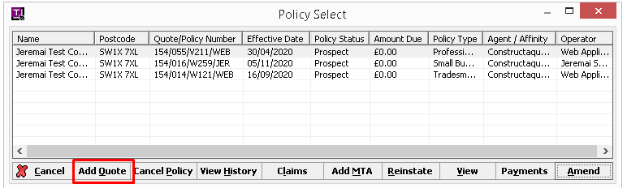
2. Select the Agent and Product from the Product Selection screen and click **OK**.
3. Fill in the quote screens, clicking **OK** or **Next** to progress through the screens. If you are amending an existing quote, the previously filled in screens can be accessed from the **User Screens** menu on the User Summary screen:   
   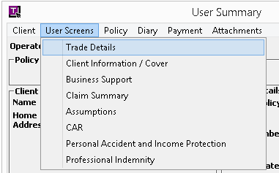
4. Upon reaching the User Summary screen, click **Quote**. Be sure to enter an Effective Date later than the end date of the Scheme (if applicable) and then **OK**.
5. The Scheme should appear in the list of quotes with ‘Refer’ in the Refer/Decline outcome column. Double-click this row and check the message shows the correct referral reason.
6. Respond to the ticket on the Monday.com board, advising that changes are now ready for testing.

# Release to live TGSL

After the ticket is approved for live release follow the instructions for the relevant type of Scheme:

## New style Scheme (calculator function)

1. Launch SQL Server management Studio and connect to **MHGSQL01\TGSL** (live)
2. Open the previously saved release script
3. Execute the script in the **Calculators** database
4. Respond to the ticket on the Monday.com board, advising that changes are now live
5. Copy the release script to the relevant Git location for the Product objects, i.e. GIT\TGSL\LineOfBusiness\Projects\<Product Code>\SQL   
   Note some Scheme folders have a separate subfolder for functions, for example:  
   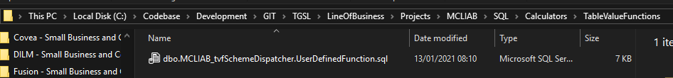
6. Commit the changes in Git and push to the Github repository

## Old style Scheme (WPD file)

1. Copy the amended WPD file into the live folder L:\TCAS\Schemefiles, replacing the existing file
2. Respond to the ticket on the Monday.com board, advising that changes are now live
3. Copy the WPD file to the relevant Git location for the Scheme, i.e. GIT\TGSL\LineOfBusiness\Projects\<Product Code>\Schemes\<Scheme name>, replacing the existing file
4. Commit the changes in Git and push to the Github repository